**Borrowers’ name: Mdm.Cheng Sokha and Mdm. Touch Hour**

**Photo of property to be pledged**

**Photo taken on 25/11/2016 by Roeurn Sarak**

**Address of property: # 2, Street No. 99 corner 466, Phum No. 6, SK Boeung Trabek, Khan Chamkarmorn, Phnom Penh city.**

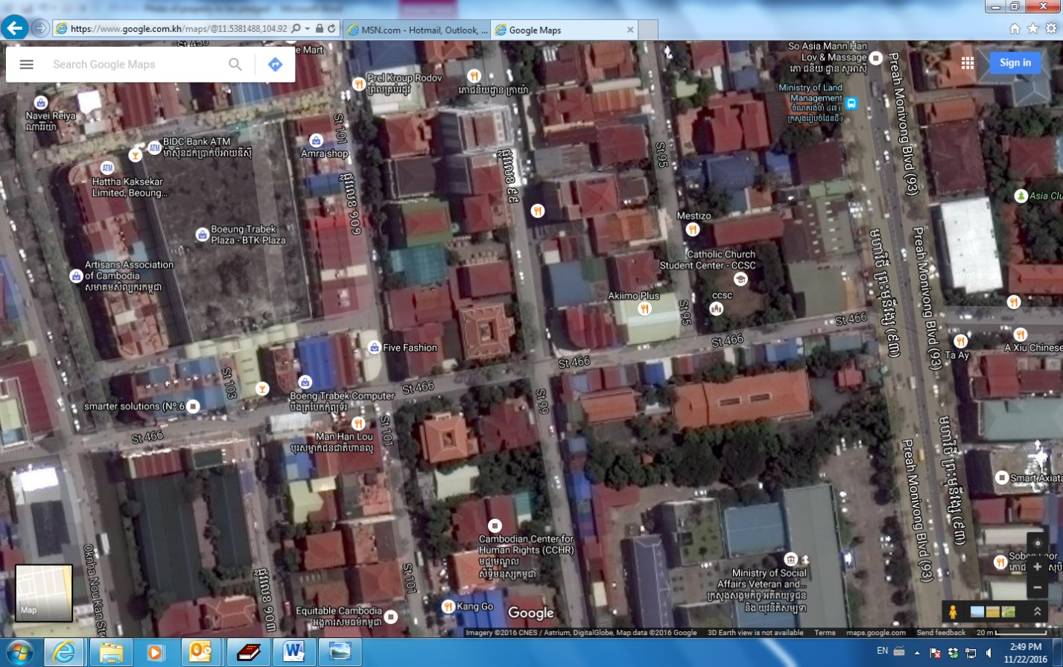

**Subject of property to be pledged**

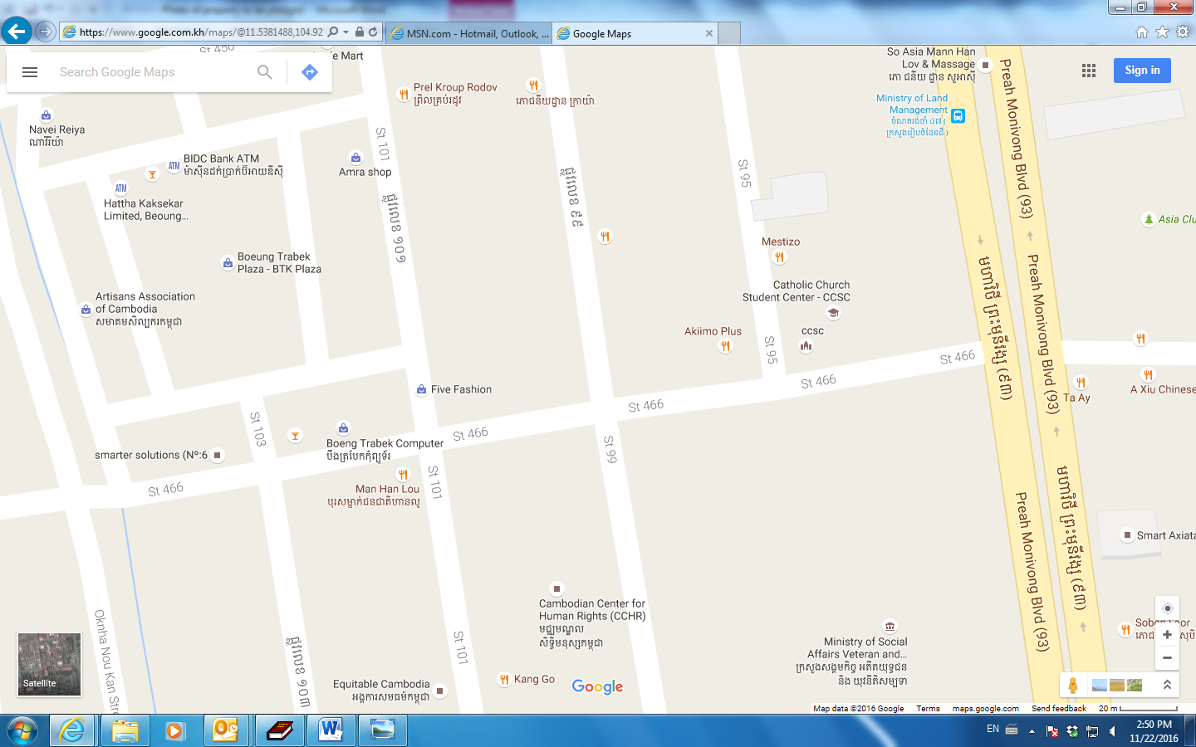d

